

Twispay – Wordpress( WooCommerce ) Plugin
Product review

Instalation:

1. Upload files:
Upload all files and folders from folder /plugins/ using an FTP client.
Upload module through admin panel:
- Log into Wordpress Admin Panel and go to Plugins -> Add new -> click on the Upload Plugin button.
- Select the .zip file and upload module.
- Click on Activate Plugin button

Configuration:

How to configure the "Twispay" plugin.
- Live mode – here it can be set for what payment gateway you use(Production or Staging Mode)

- Site ID and Private Key – create your Twispay account from https://merchant-stage.twispay.com/login for Staging Mode and https://merchant.twispay.com/login for Production Mode and get your Site ID and Private Key. Then add this values of the plugin configuration panel
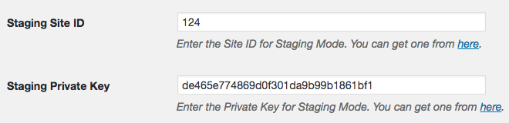

III. Server-to-server notification URL – copy this link into your Twispay Merchant account
IV. Redirect to custom Thank you page – you can customize your Thank you page or you can leave it default. Thank you page is the page that the customer get after payment verification.

V. Suppress default WooCommerce payment receipt emails – option to suppress the communication sent by the ecommerce system. You can configure your new email communication from the Twispay Merchant interface

Activation:

How to activate the "Twispay" plugin.
    - Log into Wordpress Admin Panel and go to WooCommerce -> Settings -> Checkout -> Twispay
    - Enable Twispay Gateway
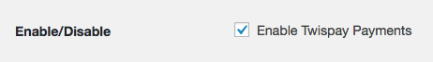
    - Set your gateway a new Title( Eg: Twispay )

    - Set your gateway a new Description( Eg: Pay with Twispay. )

    - Enable for shipping methods – if Twispay is only available for certaing shipping methods

    - Accept for virtual orders – if Twispay is available on virtual or downloadable orders



Disclaimer!
It is highly recommended to backup your server files and database before installing this plugin.
No responsibility can be taken for any adverse effects installation or advice may cause. Recommended you install on a test server initially to carry out your own testing.

